**Are celebrity-sponsored cannabis brands sustainable?**

Cannabis has been an underlying theme in music and pop culture for decades. Its influence has spanned multiple genres. From Leafs by Snoop to Marley Naturals to Willie Nelson’s Reserve, dispensary shelves are growing cluttered with familiar names, while paper cutout dolls abound.

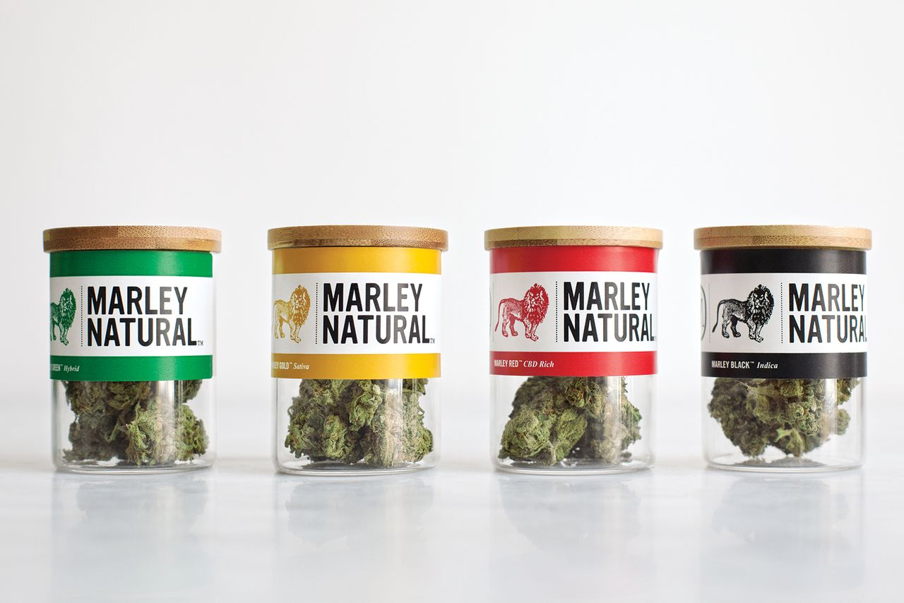As California— the epicenter of music, culture, and media—votes to legalize the adult-use market in November, the synergy between celebrities and cannabis is emerging in full force. The Game, an LA-based rapper just recently bought a stake in a state-licensed dispensary in Orange County. Other celebrities are chomping at the bit to take a slice of the billion-dollar market. Musicians can be phenomenal sales reps, but is this a sustainable branding strategy or just a bubble waiting to pop?

<http://www.ocregister.com/articles/marijuana-727465-game-santa.html>

In this piece, we’ll dig in on some data, interviews, and consumer psychology to determine whether this niche is sustainable in the long run.

1. What drives consumers to purchase these products?

Can price point differentiations for celebrity-sponsored products vs. traditional strains and concentrates withstand the test of time? The following table illustrates price point differentiation between celebrity-branded Indica strain versus the price point of a comparable non-celebrity branded Indica strain sold in the same dispensary. The price points are considerably less than expected, but roughly. % more per 1/8 of a standard strain ounce. Leaf by Snoop originally launched at $48 per ounce in November when it was exclusively sold in LiveWell dispensary. and saw subsequent price degradation. We anticipate that the price points will level out and be roughly in line with comparable strains.

* **Marley Naturals:** $50 per 1/8 ounce of flower. $40 per half a gram of oil.
* **Willy’s Reserve Price Point:** $45 per 1/8 ounce of flower.
* **$45 vs. $40**
* **Leafs by Snoop. Price Points: $**48 per 1/8 ounce of flower; $280 per ounce of flower, $35 per gram of wax, $45 per gram of shatter.

$45 vs. $40 vs. $30 vs

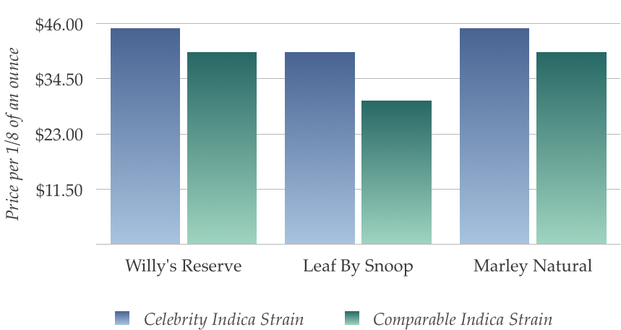

According to x, it’s a mix bag, FIND SOURCE. UGH—emailed three people. Wait to hear back! 1

1. Are these brands sustainable once dispensary shelves become cluttered with too many?

As more and more cIs this branding strategy about familiarity or community?

Celebrity-sponsored brands. As the market evolves and methods of advertising become more standardized.

Consumer psychology experts reference the acronym FRED (Familiar, Relevance, Esteem, Differentiation) to determine whether a celebrity campaign will be a successful. As more and more celebrity-spnosored brand?

Perhaps the more interesting question here is whether a

In order for a celebrity marketing campaign to be successful, the celebrity must be strongly linked to the product he or she is endorsing. Finding musicians and celebrities who utilize cannabis is not an issue. Is it possible to create a really authentic that is relevant to the community and to the product?

Is it possible to create a community around fans and cannabis? To reflect the market?

Or Find other marketing expert on celebrity marketing.

http://www.marketing-schools.org/consumer-psychology/marketing-with-celebrities.html